Project Sprint #1

The Solitaire game is described in CS449HomeworkOverview. You should read the description very carefully.

In this assignment, you aim to specify the requirements (i.e., user stories and acceptance criteria) of the target software that allows a human player to play a Solitaire game. These requirements will be fully implemented by the end of sprint 3. The minimum features include choosing the board size and type, starting a new game, making a move, determining if a game is over. The following is a sample GUI layout.

Board size
7
Board Type  - English  - Hexagon  - Diamond | 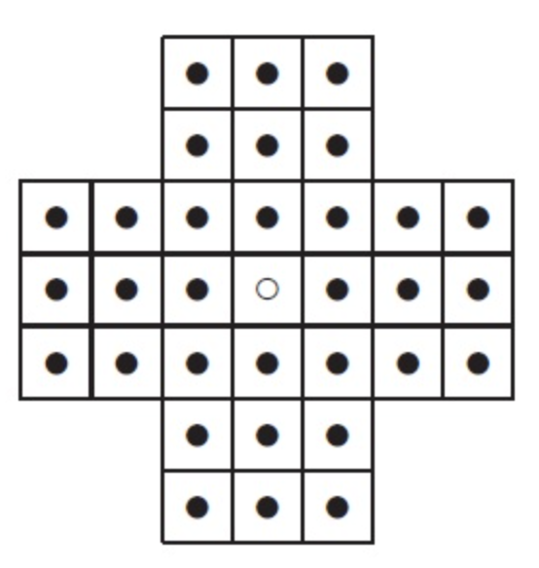 | New Game
Figure 1. Sample GUI layout of the first working program by the end of Sprint 3

Use the following tables to document your user stories and acceptance criteria.

You are required to use the free ChatGPT or another LLM to complete two user stories and two of their respective acceptance criteria. You must ensure that the generated user stories are correct and fix them if not. At the end of the submission, provide screenshots of your LLM prompts and answers, along with the description of errors the LLM made that you had to correct. Points will be deducted if no screenshots/description are provided.

For the other user stories and acceptance criteria, you are not required to use LLM.

- User Stories (3 points)

- User Story Template: As a <role>, I want <goal> [so that <benefit>]

ID | User Story Name | User Story Description | Priority | Estimated effort (hours)
1 | Choose a board size | As a player, I want to choose a board size so that I can change strategies and difficulty | 4 | 2
2 | Choose the board type | As a player, I want to choose the board type so that I can have replayabillity | 5 | 1
3 | Start a new game of the chosen board size and type | As a player I want to start a new game of the chosen board size and type so that I can play the game with different board types and sizes | 3 | 3
4 | Make a move in a game | As a player I want to make a move in a game so that I can successfully play and enjoy the game | 1 | 4
5 | A game is over | As a player I want to know when the game is over so that I can know when to start a new game and whether or not I have won or lost. | 2 | 3

- Acceptance Criteria (AC) (12 points): Add/delete rows as needed.

User Story ID and Name | AC  ID | Description of Acceptance Criterion | Status (completed, toDo, inPprogress)
1. Choose a board size | 1.1 | AC 1.1 - Select a valid board size  Given - The peg Solitaire game setup screen is displayed  When - The player selects one of the available board sizes  Then - The selected board size is displayed as the current choice | toDo
1. Choose a board size | 1.2 | AC 1.2 Start game with the selected size  Given - The player has selected a valid board size  When - The player starts a new game  Then - A peg solitaire board matching the selected size is displayed | toDo
1. Choose a board size | 1.3 | AC 1.3 No board size selected  Given - the player has selected a valid board size  When - The player starts a new game  Then - A peg solitaire board matching the selection is displayed | toDo
 | 1.4 | AC 1.4 Invalid board size  Given - The player is on the game setup screen  When - The player selects English, Hexagon, or Diamond  Then - The invalid size is rejected and an error message indicates that a valid board size must be selected | toDo
2. Choose the board type | 2.1 | AC 2.1 Select valid board type  Given - The peg solitaire game setup screen is displayed  When - The player selects English, Hexago, or Diamond  Then - The selected board type is displayed as the current choice | toDo
2. Choose the board type | 2.2 | AC 2.2 Start game with selected type  Given - the player has selected a valid board type  When - The player starts a new game  Then - a peg solitaire board matching the selected board type is displayed | toDo
… | 2.3 | AC 2.3 No board type selected  Given - the player is on the game setup screen and no board type has been selected  When - the player attempts to start a new game  Then - the game does not start and the screen displays a message asking the player to select a board type | toDo
 | 2.4 | AC 2.4 Invalid board type  Given - the player is on the game setup screen  When - the player attempts to select or enter a board type other than english, hexagon, or diamond  Then - the invalid board type is rejected and an error message indicates that a valid board type must be selected
3. Start a new game of the chosen board type and size | 3.1 | AC 3.1 The board appears on the screen with the valid type and size  Given - I picked a board type and size  When - I start a new game  Then - a board with the selected type and size appears | toDo
 | 3.2 | AC 3.2 Every hole on the board has a peg except for the center  Given - I started a new game  When - I view the board on the gui  Then - every hole has a peg except the hole in the middle of the board | toDo
 | 3.3 | AC 3.3 Selecting new game in the middle of a current game restarts the game  Given - I am in the middle of a game and the board has pegs removed  When - I click new game  Then - the board goes back to how it started with all holes filled with pegs except the center | toDo
 | 3.4 | AC 3.4 The peg count equals all of the holes minus one  Given - the board appears on the screen when i start a new game  When - a new game is started  Then - all of the pegs on the board equal the same number of holes - 1 | toDo
4.Make a move in the game | 4.1 | AC 4.1 A legal move is valid and the peg moves and removes the jumped peg  Given - a peg has a peg next to it in a hole and there is an empty hole past it  When - I click the peg and then click the empty hole  Then - my peg lands in the empty hole and the jumped peg disappears | toDo
 | 4.2 | AC 4.2 There are no pegs to jump over  Given - A peg has an empty hole directly next to it and then another empty hole past that hole  When - I click the peg then the farther hole  Then - nothing moves | toDo
 | 4.3 | AC 4.3 The landing spot for the payed peg is taken  Given - a peg has a peg next to it but no hole for landing past it  When - I click the peg to move to the spot with a peg in it  Then - nothing moves and the play state stays the same | toDo
 | 4.4 | AC 4.4 Clicked the same peg twice  Given - I selected a peg to play  When - I click the same peg a second time  Then - the original selection gets removed | toDo
 | 4.5 | AC 4.5 Starting from a hole that is empty  Given - the board is appearing on the screen  When - I click on an empty hole with no peg to move  Then - nothing happens and the game continues | toDo
5. A game is over | 5.1 | AC 5.1 one peg is left on the board  Given - the previous move i made leaves a single peg on the board  When - the move is finished  Then - the game ends and outputs a message to the user | toDo
 | 5.2 | AC 5.2 The game is not over yet  Given - I previously made a move and there are more than one peg and a legal move is still an option  When - I am finished making my move  Then - the game continues on | toDo
 | 5.3 | AC 5.3 Cannot play after the game is finished and a result is printed  Given - the game has ended  When - i click a peg and make my final move  Then - the game ends and a message is printed to inform the user | toDo
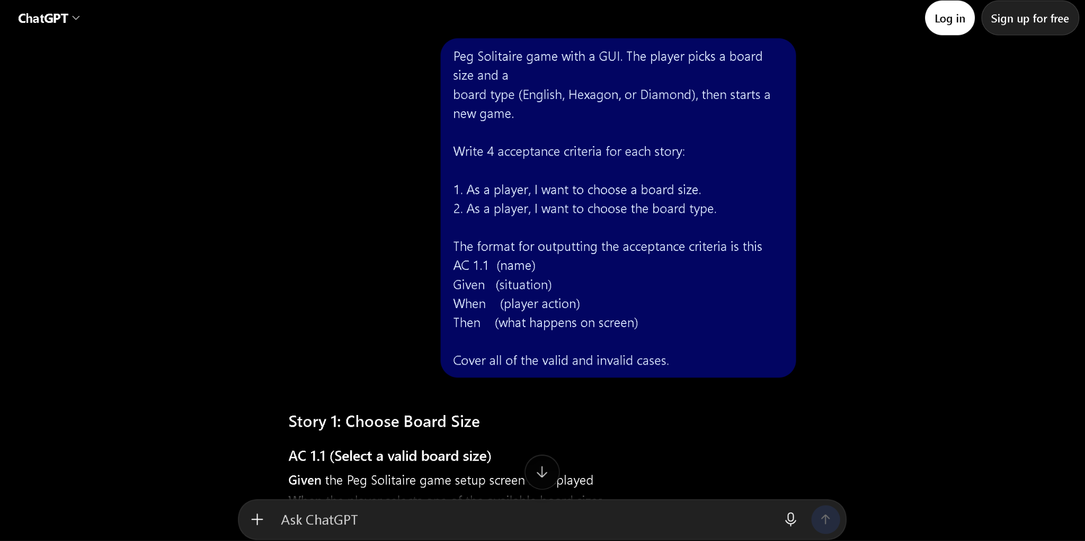
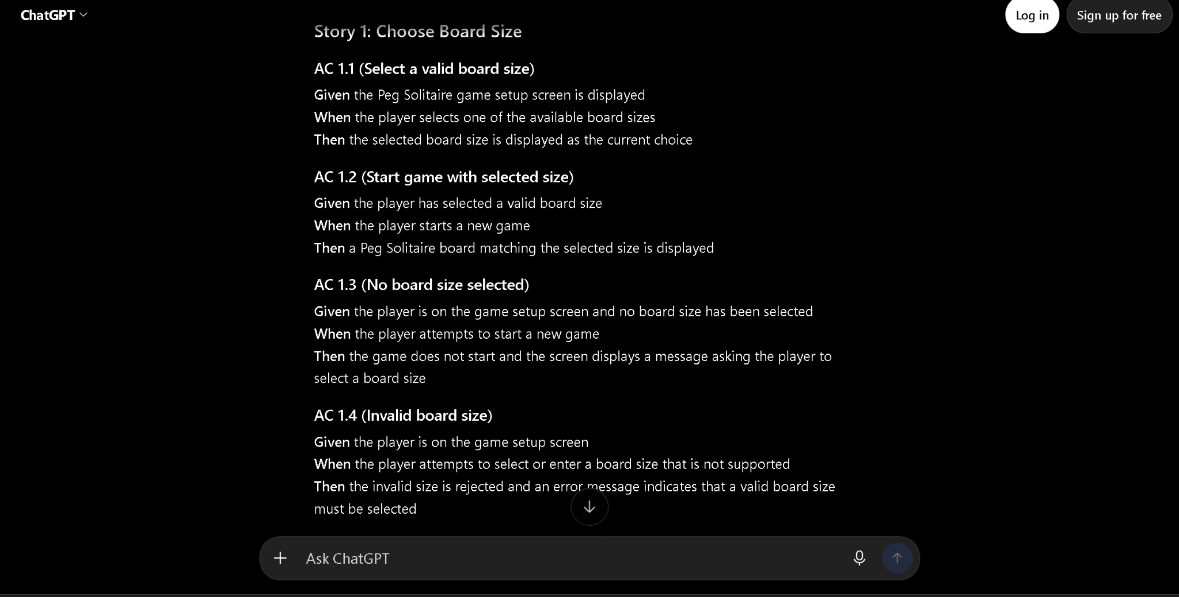
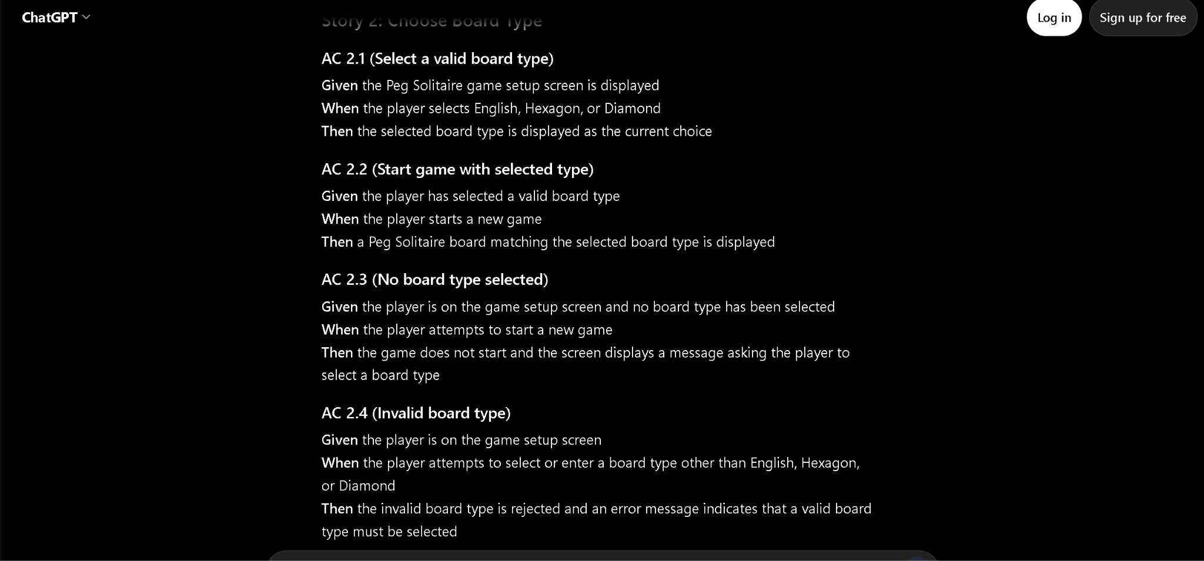

The LLM chosen was chatgpt, since I was not logged in it went strictly off of the original prompt I wrote to it. The errors that it made were that it tended to be very vague when it came to the acceptance criteria. An example of this is on the AC 2.4 for invalid board type. In reality there would be no way for a user to select a invalid board type because the user will be forced to select a valid board type.

